2026 Census, Harvest, Sorting and Processing Methods
CO2 x N Experiment
Updated July 14th 2025 by AP
(Note: see census-harvest tool kit folder for a record of changes to this protocol)

Density Double Counts

A week before census begins a group of 6-9 individuals should be indicated to perform Density Double Count duties. Prior to performing actual counts this group of individuals will need to attend a training session to calibrate counting amongst each other. These calibrations procedures are outlined in pre-census double count document.

Density Counts are done by using 3 teams of 3 individuals on the Friday the week before the census is conducted. It is important to note we want this count to be done as close to the dates slotted for census measurements and must be done less than a week prior to last day of census measurements.

Each member will count all the green and all yellow stems in the quadrat. They will also be keeping track of stems that are below the height of the plot square regardless of color. Keep the number of stems you’re counting manageable by dividing the quadrat into four subsections using sticks (i.e. lay the sticks across the permanent aluminum quadrats). The person counting will record three separate number numbers, the total number of stems (Total=green+yellow+stems under grid) and includes stems under grid height), The yellow stems and stems under grid height are part of the total number of stems but will also be separately recorded in the data sheet.

Dead Stems: These are not counted in the total count.

Green stems: Stems that are green at any point of the stem and have a measurable green height >0.

yellow stems: meaning there is no green in the stem, but you can tell by the color that the stem was grown withing the particular year cycle.

Stems under grid height: These are stems green/yellow that’s height is below the plot square.

Each plot is counted twice. Once by each of the two members of the team. The requirements for density count allowable error are listed below. If these requirements are not met a third count is conducted from another trained counter outside of the counting group.

>30 stems = Double counts must match with 0 error
31-40 stems = 1 stem error
40-59 stems = 2 stem error
60-79 stems = 3 stem error
80+ stems = continue to use 5% allowable error

If there were more than 2 counts made, then the two best counts must be circled prior to the datasheet being scanned.

Note: Many of the chamber’s panels haven’t been take off all growing season and wasps seem to like nesting in the dead stems where they can blend in with the foliage. Doing a wasp check before counting is highly recommended.

Note: 2025 only. Prior to counting to standardize the height of the grid we used a foldable ruler to adjust the height of the grid to 30cm. When conducting the count any stems that were below 30cm we counted separately but still included in the total count.

SCAM Allometry (primarily supervised volunteers)

- Remove 6 of the 8 panels on the chamber to be measured; the two panels left in place are those in the SET measurement corridor with no harvest quadrats. There are a total of 8 permanent aluminum quadrats to sample at each chamber, six inside (Q1-Q6) and two outside (Q7 and Q8). The location of Q1-Q6 is stamped into the manifold, with the quadrats starting 10 cm buffer from the chamber edge (see maps below).

Note: Because some chambers are inverted from this diagram the numbers do not always run clockwise (see figure below)

- Measuring is conducted with teams of 3 people. 1 person will be recording, and 2 people should alternate measuring plants.
Recorder: (i) Look at data sheet and make sure it matches the experiment, chamber, and subplot. (ii) The total height ≥ green height, (iii) cross out wrong data with a single mark so it can still be read or use the extra greyed-out lines at the end of the sheet.

Measurer (2 members): (i) check caliper zero, (ii) if obvious measure widest edge of stem, (iii) do not skip the smaller plants. (iv) Make sure you are using plot stickers to accurately report plot position.

- Measuring. Though we count all the stems, we will only measure height and width on up to 30 stems in the quadrat. Subdivide the quadrat using sticks. To avoid biasing our selection of stems, measure all the stems in one subsection first and then go to another, until you reach 30. Some quadrats will have less than 30, in which case you read them all. Record the total height, green height and width at half height of each schoenoplectus stem in the quadrat. Green height is defined as the height below which the stem surface is consistently over half green. Small, individual brown spots (likely caused by herbivores and not senescence) do not count as interrupting the green height. Do not count dead stems (brown or grey). Measure width at roughly half the total height and along the widest face of the stem (schoenoplectus is not always equilateral). Two people measure separate quadrats while one person records numbers, keeping the data from each quadrat separate.

- Note plants with open flowers as “Y” (i.e. Yes flower); stems with unopened buds as “N” (i.e. no flower); and those with a broken or cut-off top (can’t tell if there was a flower) as “C”. Thus, all stems should have one of these three notations: Y, N, C.

- Once each quadrat has been measured, move to another quadrat. We usually start one reader on Quadrat 1 and one on Quadrat 5, and each moves up in numbers (1->4, 5->8) so that they don’t get too close to one another.

OTHER Species Density and Allometry (primarily trained technicians)
Identify and measure height and width (40 cm height) on all stems in each quadrat that are not Schoenoplectus, Spartina or Distichlis. Use the separate “OTHER Species” datasheet to record the data. Confer with other experts or the herbarium sheets to check identifications. This should be done by the same person (or same lead if in pairs) for the whole experiment.

Adam or other floating supervisor fills out the “Other Species” census form by counting the number of stems that are not SCAM or grass in the entire chamber, regardless of species identity. Measure the dimensions of any “other” stems only if they fall inside a quadrat.

Harvest (Adam will normally do this)
1. At a predetermined point on each of the eight census plots, drop a flag from just above the canopy. The predetermined target point changes each year: (2017: front left, 2018: front right, 2019: middle left, 2020: middle right, 2021: back left, 2022: back right). Insert the square by sliding the bottom left corner of a three-sided subsample square down the flag pole. The clipped plot occurs adjacent to, but not inside the permanent quadrats, so the order of operations (count, measure, harvest) is unimportant.

Note: It is important to follow the flag’s placement and maintain a consistent orientation relative to the flag in order to achieve an unbiased location. Otherwise, there is a temptation to sample vegetation that does not occur in the 5 x 5 square.

2. Complete the fourth side of the square by circling your thumb and finger to close the open end of the template. Clip the contents of the 5 x 5 cm square for biomass.

3. Grab the vegetation rooted therein and clip the plants within 1 cm of ground level. You do not need the thatched litter above the template; you can sort it out later if necessary.

4. Place the vegetation in a pre-labeled bag numbered with the plot and the quadrat (1-8). MAKE SURE the paper bag is properly labeled. Take these bags to the shed for sorting. We sorted all clipped vegetation as we went.

Sorting (primarily supervised volunteers)
- Separate into four categories:
  - Schoenoplectus: The sedges have edges and are easiest to separate. Separate green sedge from brown sedge. Define ‘green’ any stem that has a green part, no matter how small. Count the number of green stems as you are sorting. Put completely dead material in a discard pile. On the “harvest” data sheet, Schoenoplectus section, record the number of sedge stems. Go to step 2.
  - Spartina: The fine flowing grass. Separate green grass from brown grass. Define ‘green’ any stem that has a green part, no matter how small. Put completely dead material in a discard pile. Count the number of green stems as you are sorting, record the number on the Harvest datasheet in the Spartina section. Go to step 2.
  - Distichlis: The striped, thick-stemmed grass. Again, count as ‘green’ any stem with a green part, no matter how small. Put completely dead material in a discard pile. Count the number of stems as you are sorting and record the number in the Distichlis section. Go to step 2.
  - Other Species: Identify other species and count the number of stems. Be sure to ask for help identifying plants. Separate green plants from brown plants. Put completely dead material in a discard pile. Count as ‘green’ any stem that has a green part, no matter how small. Record the ID of the species and the number of stems first under Misc #1 or else Misc #2. A table of IDs for each species is available on the sorting tables. Go to step 2.

- Before putting the samples into their respective bags, rinse all samples by swishing them in dip bucket to remove salt, silt, or dirt.
- After sorting, try to weave the grasses into little bundles; it will be much easier to weigh after it's dry, otherwise it gets brittle. Place each of the remaining categories (Spartina, Distichlis, or Other) in their own bags.
- Use bags pre-labelled with “CO₂ x N Experiment” fill out Chamber, Quad (quadrat), Species, Stem Count, and stamp the date.
- On the mass sheet checklist, place enter the number of stems in the appropriate column as you go. Most quadrats won’t have all four categories, so we need to keep track of the quadrats that produced samples vs those that did not – so put a zero (0) in blank cells to indicate there was no sample.
- Discard the dead stuff.

Processing for Weight
- Place sorted samples in the drying oven for at least 96 hours @ 60 C. The bags should be spaced appropriately, not too crammed together, so that each is exposed to moving air and can fully dry.
- Find or reprint “CO2xN Harvest Data” Sheets collected during the annual harvest. This is where you will be recording the mass.
- Be prepared to weigh the bags shortly after removing them from the oven. Remove dry bags from oven, allow them to return to room temperature for 20 minutes.
- Use standard 50g and 1g weights to check calibration of scale, and record values on mass data sheet. Remove the sample from the bag and weigh it on a balance with at least 3 decimal places. Record weight in corresponding cell of the mass data sheet to 3 decimal places.
- After weighing samples from a single chamber, consolidate samples according to species into sections USGS (U), Biogeochem (B), and Control (C). Put all the green stems from a single species and section (U/B/C) into a single bag for grinding. Label consolidated sample bags clearly with Experiment, Year, Chamber #, sample Species Code (SCAM/ SPPA/ DIST) and section (B/C/U).
All aboveground biomass sample bags are marked B, C or U, which corresponds to where they were taken. B and U are inside the chamber, C is the adjacent un-chambered control plot.

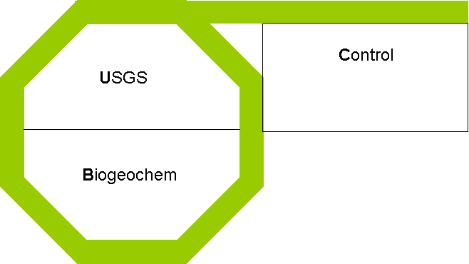
U includes quadrats 1, 5 & 6
B includes quadrats 2, 3 & 4
C includes quadrats 7 & 8

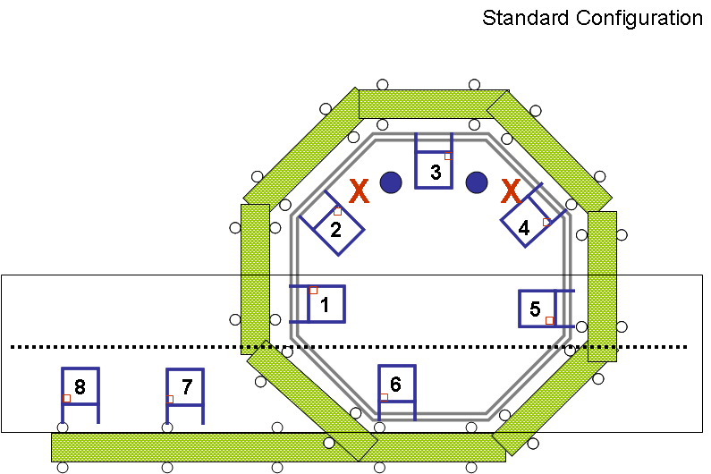

B

C
U

- This step is only for Schoenoplectus stems: remove any dead areas from the stems prior to consolidation. Remove brown tip and sheathing on base of the stem; grind just the green tissue.
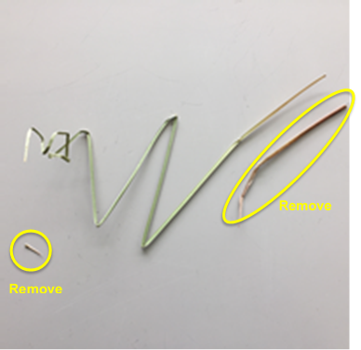

Grinding Labels

- Prior to grinding 20mL scintillation vials need to be labeled. Start by opening vial labelling document and printing on weatherproof address labels.
S:\Biogeochemistry\GCREW\2-CO2xN Experiment\1-Plant Biomass & CN Data\Shoot Biomass Data\Census-Harvest Toolkit\Labels\ “2M Aboveground vial labels (Master List)”
- Use the weight data from the Harvest Data Sheet to figure out which plots need vials. Samples of the same species have been combined for each chamber and section (U/B/C). Look at data for each chamber individually to see which species are present. A vial and a label are required for each species present. Go through each chamber one at a time, adding labels to vials as you go. Put vials back into the box in order until all 20 chambers are done.
- After all side labels have been added, label the caps of the vials with the information shown below, using the corresponding side labels as reference.

2020 2M CO2xN CH 1 U SCAM

SCAm

Year 2M CO2xN Ch# / Section Species

Example

Pre-Grinding Steps
- After vials and tops are labelled, organize harvest bags to correspond with the order of the labeled sample vials.
- Check each paper bag to see how much sample is inside. When there are more than 1 grass or schenoplectus stems, cut stems into smaller pieces with scissors or for larger samples use coffee grinder. The coffee grinder will have to be cleaned between each use.
- Print Grinding checklist to keep track of progress as samples are processed.
S:\Biogeochemistry\GCREW\0-GCREW-Wide Data\1-Sample Tracking\Shoot Biomass\ “2-CO2xN (2 m) Shoot Grind Checklist”
How to Grind Samples
- Prior to starting find 4 stainless steel capsules next to grinder remove O-ring from the lids scrub O-ring and capsules with Ethanol to remove any sample traces from other experiments. After scrubbing everything down with ethanol rinse thoroughly with DI and dry with Kim Wipes.
- Open the lid of the grinder and inspect the belt look that its set on the track and there in no dry rot or nicks to the belt. Look at ball joints where the capsules spin. Look for rust and move the joint around with your hands feel for resistance. If there is rust or resistance spray joints with WD-40 and move them around.
- Turn on switch located on the back panel on the lower right corner. Set the time to 7 minutes 30 seconds.
- Fill capsules ¼ or less full. Secure the lid tightly and put capsules into the mixer mill.
Note: If capsule is too full the plant material will not grind to fine powder.
- Close the Lid and hit the start button. While samples are in the mixer mill listen for sounds that may indicate the capsule has loosened. Be prepared to hit the stop button or cut the power by flipping the switch in the back.
- While one set is grinding, start processing the previous set of samples and start preparing the next set of samples to be ground.
(NOTE): We grind everything that we have enough sample to grind (SCAM, SPPA, and DISP in all sections U, B, and C.) Samples should be ground finely and put into scintillation vials which are clearly labeled with (Chamber #, year, sample species code SCAM, SPPA, DIST, And Section B,C,U)

Choosing Samples for C:N+Isotope Analysis (added 2014)
1) Analyze all roots.
2) Analyze Schoenoplectus from the B sector of all chambers.
3) Analyze grass from all the B sectors that had enough to grind.
4) Randomly pick 5 of the 20 chambers for an analysis of C sector (control) plants. The random selections were generated in Excel through 2023 (see table below). Take plant samples from quadrats 7 and 8 for Scirpus, Spartina (if it is present), and Distichilis (if it is present). Composite samples from the two quadrats for a single sample from that chamber.

Randomly generated numbers for selecting control chamber plots (quadrats 7 & 8) to be analyzed for C and N content. Composite samples from quadrats 7 & 8 will be analyzed for Scirpus, Spartina (if present), and Distichilis (if present).
2013 | 2014 | 2015 | 2016 | 2017 | 2018 | 2019 | 2020 | 2021 | 2022 | 2023
1 | 4 | 3 | 1 | 2 | 2 | 3 | 4 | 4 | 4 | 2
7 | 6 | 7 | 6 | 5 | 7 | 7 | 5 | 5 | 6 | 6
12 | 11 | 12 | 9 | 12 | 10 | 12 | 9 | 11 | 10 | 11
14 | 13 | 15 | 15 | 15 | 14 | 13 | 16 | 16 | 14 | 13
19 | 19 | 19 | 19 | 17 | 19 | 20 | 20 | 17 | 18 | 17

Randomly generated numbers for selecting control chamber plots (quadrats 7 & 8) to be analyzed for C and N content. Composite samples from quadrats 7 & 8 will be analyzed for Scirpus, Spartina (if present), and Distichilis (if present).
2024 | 2025 | 2026 | 2027 | 2028 | 2029 | 2030 | 2031 | 2032 | 2033 | 2034
7 | 2 | 6 | 7 | 5 | 3 | 6 | 3 | 5 | 7 | 2
10 | 3 | 9 | 8 | 6 | 6 | 9 | 5 | 9 | 10 | 3
12 | 7 | 10 | 16 | 7 | 7 | 10 | 7 | 12 | 12 | 13
17 | 9 | 15 | 17 | 14 | 13 | 11 | 10 | 13 | 17 | 15
19 | 20 | 16 | 19 | 15 | 14 | 13 | 16 | 17 | 19 | 20

Data Entry
* Enter the average of the double counts. If the average results in a fraction round up to nearest whole number.

* Be aware that the following validation rules are used in the Excel template:
1M Normal range: 20cm-160cm
2M Normal range: 20cm-180cm
SMARTX Normal range: 20cm-180cm
